**HOME PAGE**

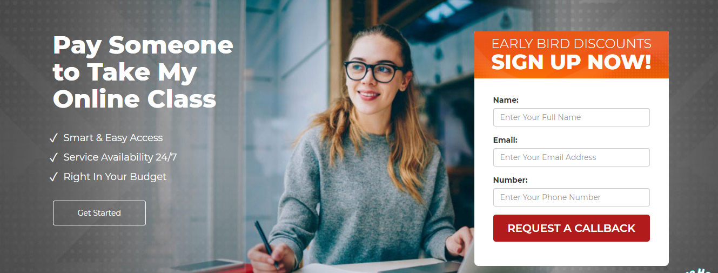

**SIGN UP HERE**

**DISCOUNT FOR NEW COMERS**

DIC

NAME:

EMAIL:

NUMBER:

PAY ME TO HELP YOUR CLASS ONLINE

* 24/7 available
* Affordable
* Simple and smart

BEGIN NOW

**BE IN TOUCH AND CALL UP**



* 87% happy customers
* 1100+ online class attended
* Completely secure
* Attended by professionals

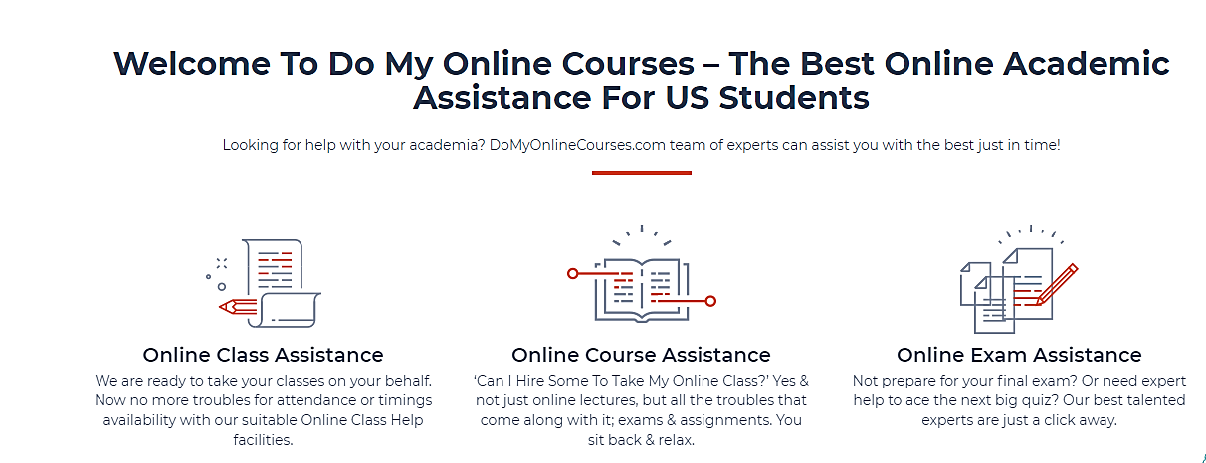

Welcome here to help my class online with 100% best results- best online academic for US students

Are you looking for someone to help my class online for me? So here it is, helpmyclassonline.com is the leaders. Hire us to get help in online class now.

**Class Assistance Panel:**

We are ready to help your class online. No more difficulties to attend online class on time. Abc.com has helped my class online facilities.

**Assist my class online**

Can I hire someone to help my class online? Yes we can help to take your class online just by paying at helpmyclassonline.com

**Pay us to help my class online for me**

Have some issues to take your class online? Stay hassle free our experts are here to help you in online classes.

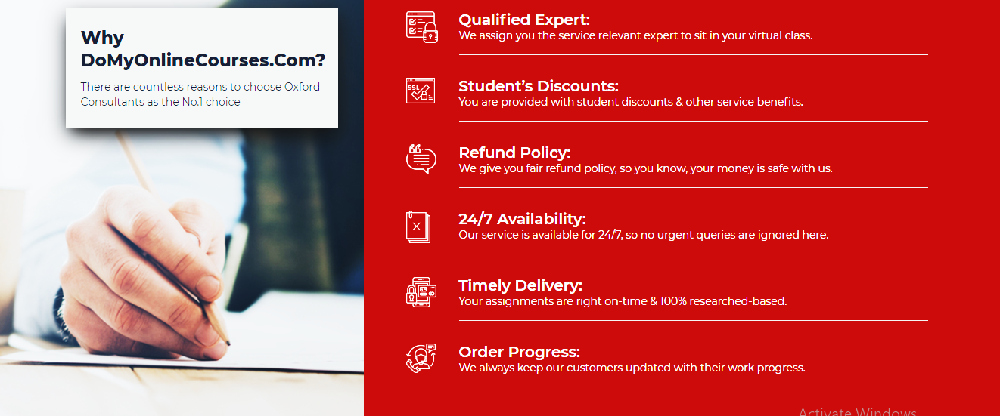

**Early bird discount**

To our new customers, we will give discount and help to take my class online.

**100% refund policy**

If you are not comfortable with us and we can’t take your class online that is why we have provided refund policy. That means your money is safe with us.

**Punctuality**

We will help you in classes online and your online classes are timely attended to help you in get 100% attendance.

**24/7 availability**

Helpmyclassonline.com is 24/7 available. You can easily contact us and pay us to do your classes online.

**Qualified experts**

Looking for someone to help My Class Online for me? Relevant expert sit in your virtual class and give all answers to the professors.

**Updated:**

Helpyourclassonline.com keep updated the customers by attending the class.

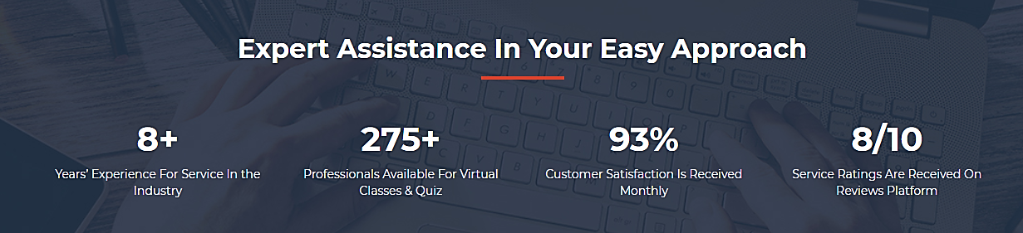

**Qualified experts assistance**

9+ experience for service of attending online classes

350+ professionals available to answer different questions of professor

97% happy customers in a month

9/10 service rating received on helpmyclassonline.com platform.

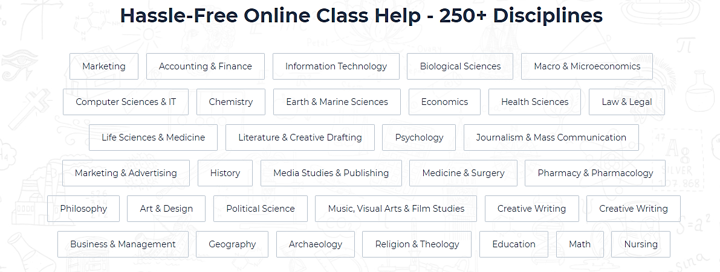

**Care free online class help**

* Medical Sciences
* Marketing
* Accounting & Finance
* Pharmacy & Pharmacology
* Education
* Information Technology
* Microeconomics
* Microeconomics
* Computer Science
* Chemistry
* Broadcasting & Mass Communication
* Medicine & Surgery
* Physics
* Economics & Finance

* Health Management
* Law
* Biomedical Sciences
* Applied Linguistics
* Psychology & Sociology
* Political Science
* History
* Business Management
* Statistics
* Media Science
* Philosophy
* Fine Arts
* Visual Studies
* Graphics
* Business & Management Studies
* Geography
* Archaeology
* Religion
* Mathematics



**John David**

**Math’s/statistics expert**   
John David is PhD expert and is highly selected to take classes online and give all the answers to professors.

**Robert Jackson**

**Business and management**

Robert Jackson is an expert in business management and attempts all the classes, discussions which are related to business.

**Hannah john**

**Pharmaceutics and zoology**

Hannah john is pharm-D and MD qualified teacher. She makes sure that all the medical related questions and quiz are given correctly.

**Elena Anthony**

**Linguistics expert**

At helpmyclassonline.com Elena helps literature students and attends online class, small assignments and quiz.

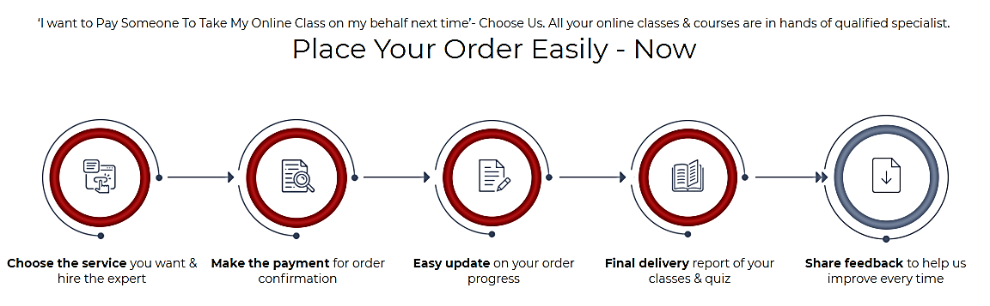

Can someone help me to take my online class for me? Choose us we are the leaders of doing your quiz and attend your classes on time.

Hire the expert according to the service 🡪 for order confirmation; make payment 🡪 get updated on your order progress 🡪 final delivered report of quiz and online classes 🡪 share feedback to improve quality

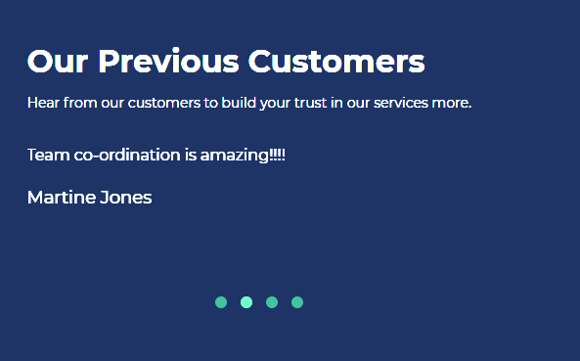

OUR HAPPY CUSTOMERS

Customers motivated feedback because they trust us.

Team coordination is astonishing.

* + - Oliver Benjamin

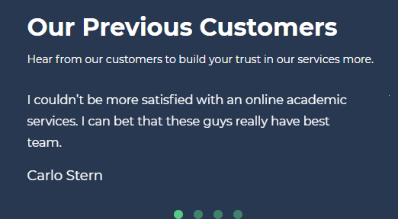

Customers motivated feedback because they trust us.

Satisfied with helpmyclassonline.com and these guys have best team.

* + - Nicolas Charlie